WEATHER APP. IO DOCUMENTATION

# 1.INTRODUCTION

This app's main purpose is to notify users about the weather information that only they want to be notified, on time they selected. This can save their time, makes them to get ready with specific weather events without checking whole weather forecast.

# 2.LITERATURE SURVEY

## Existing System:

The Existing Weather Monitoring system generally use weather stations that use multiple stations like thermometers, barometers, rain guage, wind valve etc. to measure weather and climate changes. later physically recorded and stored in database.

## Proposed System:

The System deals with monitoring weather and climate changes like

1.Temperature, humidity using the DHT11 sensor.

2.Quality of air using MQ135 sensor.

# 3.THEORITICAL ANALYSIS

## Block Diagram

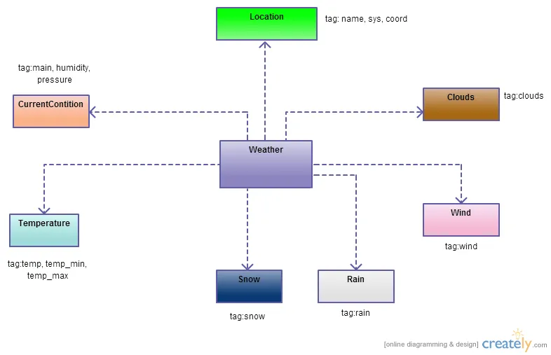

# 4.RESULT

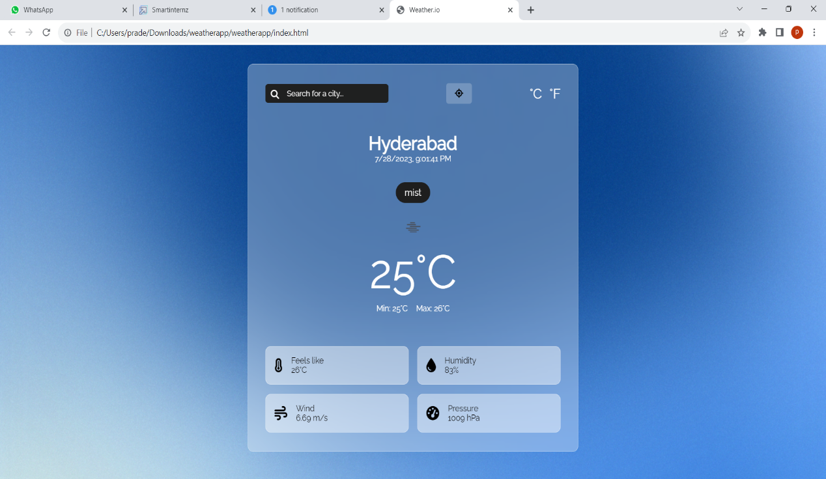

# 5.ADVANTAGES & DISADVANTAGES

# a. ADVANTAGES:

●Unlike conventional weather monitoring instruments is very small and compact allowing it to be installed easily on rooftops.

●It is light and portable; this advantage allows us to easily carry it to remote location for installation. Due to its design it can be easily be carried by a weather balloon to measure atmospheric changes at high altitudes.

●The sensors used in this product are much cheaper compared to the ones that are used in the existing weather monitoring systems making this design more cost effective.

●Due to the presence of fewer moving parts less amount of maintenance will be needed cutting down on maintenance charges.

# DISADVANTAGES:

●The current system always faces problems such as delay in warning people about bad weather and sudden changes in the forecast.

●The instruments used in the existing systems are expensive and add up to the already high cost of installation and maintenance.

●Data that is collected by the instruments needs to be manually transferred from the logger to a laptop or computer via a cable.

●Existing weather monitoring systems that are used in the field generally consist of unconventional and heavy machinery that consists of numerous moving parts that require constant maintenance and need to be manually monitored and changed frequently.

●Power requirements are one of many major constraints as these instruments are generally cited far from main power supply. This adds to the cost of using such instruments.

●The use of thermometers to measure external temperature; however accurate is still outdated and constantly needs to be manually checked for any change in temperature.

●Existing systems consist of large and heavy instruments that occupy a lot of space hence making it difficult to install them in remote locations and places which have limited space.

# 6.APPLICATIONS

1.Temperature

2.Humidity

3.Wind

4.Pressure

5.Haze

# 7.CONCLUSION

So, we conclude: in order to create a weather app and succeed, it's important to think through the logic of the program and develop a strategy of distinguishing from competitors. After all, such meteorological services are basic Android & iPhone weather apps, and you should do your best to attract the user.

If you want to build your own weather app from scratch, we’re more than happy to help you. Our team employs only experienced and skilled specialists who'll implement your idea with pleasure and inspiration.

# 8.FUTURE SCOPE

Seamless weather and climate risk-based services will be further developed, providing insights from minutes to seasons, to enable improved decision-making and risk reduction. This will include the integration of historical observations and forecasts with a full characterization of uncertainty.